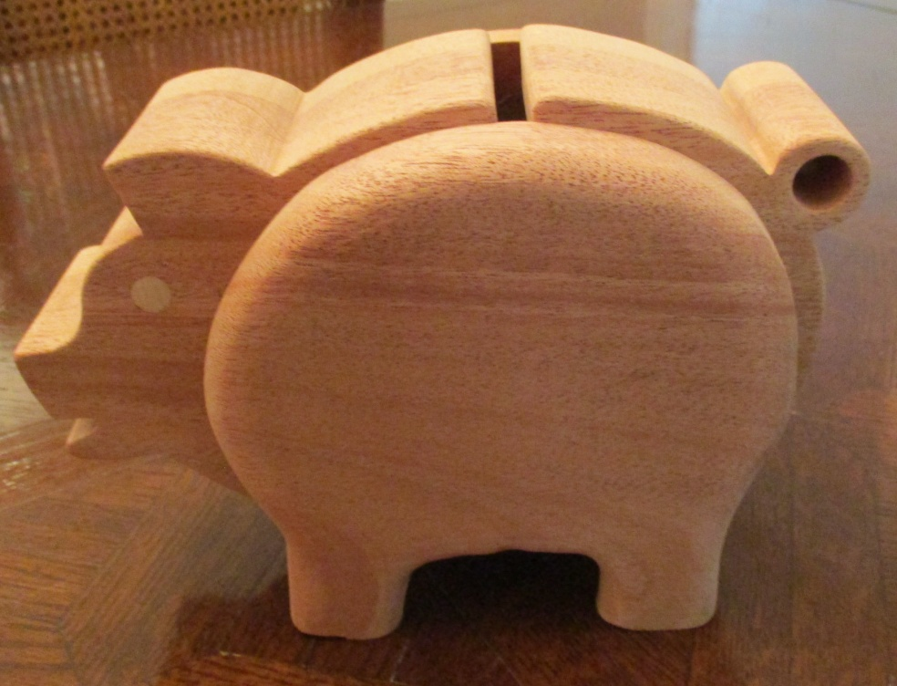

**Building the Piggy Bank . . .**

NOTE: Here are two versions of the Piggy Bank. One has a stopper, and the other a door, both of which gives access to the savings inside the bank. Both piggy banks are made exactly the same way, with the exception of the access method to the bottom hole.

1. Glue up three pieces of ¾” boards for the body. The body of my pig is 8 ¼” from snout to tail, and 5” from belly to top of back. The boards need to be a little bit bigger than this.
2. The two sides of the body are each made from ¾” boards. My side pieces measure 5 ½” shoulder to rump, and 5 ½” from the top of the back to the hoofs.
3. Choose which version of the Piggy Bank you want to make, and either trace the body and the two sides from patterns, or attach a copy of the pattern to the wood. (See below for the patterns and for different ways of attaching the patterns to the wood).
4. Mark the center of the underside of the belly, side-to-side, and drill the 1 1/4” stopper hole in the body, where indicated. Do this before cutting out the body.
5. Drill the 3/8” eye hole, and the ½” tail hole in the body. I also drilled a 5/8” relief hole in the body cavity area, to make it easier to turn the blade to start the cutting out of the center of the body. Drill all three holes all the way through.
6. Using the band saw cut the outside shape of body (you could also use a coping saw, scroll saw, or jigsaw). To make the sharp “turns”, that is, the “V” angles, cut them out by first by cutting a relief cut to its center point, and then make another cut to that center point, from a different angle. Note, the final shaping of tail can be done with a file, or a 1” belt sander.
7. Using the band saw, or other saw, cut out the ¼” coin slot first, then cut out the inside of the body.
8. Cut out the side pieces. Be sure to mark the inside of each piece with an arrow to show the direction to the front – the sides are not symmetrical! Note: you can cut both pieces at the same time by attaching the two pieces together with double sided tape.
9. Sand the inside of body, the money slot, and the stopper hole smooth
10. Slightly round over the edges of the body (“ease” the edges)
11. Round over the **outside** edges **only** of the side pieces, with a ½” round-over router bit. (Doing this step on a router table is recommended)
12. Insert, with glue, two 3/8” dowels, approximately ½” long, one in each eye hole
13. Sand all pieces smooth
14. Glue the sides to the body. Be careful, making sure they are even so that the pig doesn’t wobble. I glued one side to the body, clamped it, and let it sit for about 5 minutes. I then glued the second side on with the pig standing up, and clamped the body again: no wobble!

* If you have made the version of the piggy bank using a stopper, Insert a #6 stopper in the bottom hole, to keep the loot inside the pig.
* If you’ve chosen the version with a door, cut the door out of the “waste” piece that was the result of cutting the cavity out of the body. This way the grain and color will match the rest of the body.
* I used a 1” solid brass Narrow Hinge and half of a 2” Mending Brace as hardware for the door.
* I cut the mending brace in half using the cutting disc on my Dremel tool, and sanded the rough edge. A hack saw or other cutting tool will do the job too.
* The only caution here, when attaching the hinge to the door, is that the screws may be too long and will need to be cut, or ground down, so that they do not protrude through the back side of the door piece.

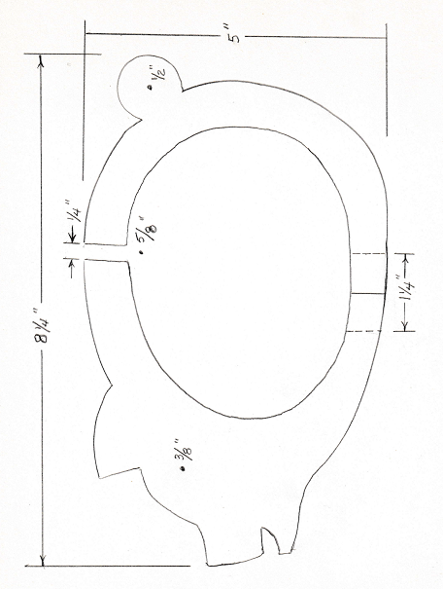

Pattern for piggy bank body with stopper access

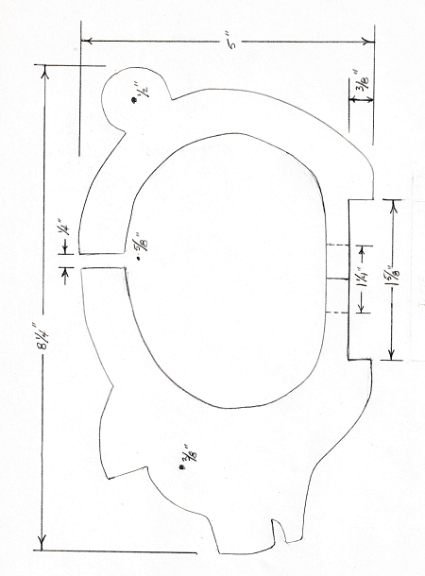

Pattern for piggy bank body with door access

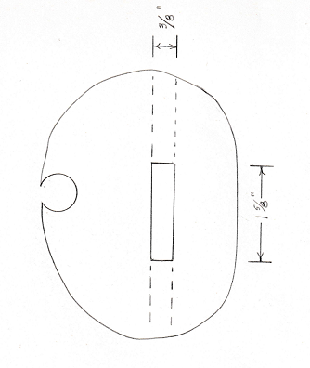

Pattern for cutting access door from cavity cut-out

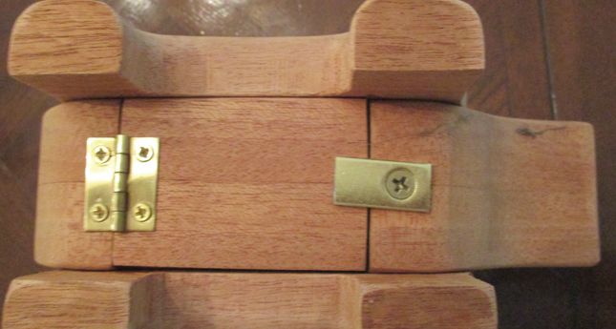

Hinge and “lock” plate on door

Pattern for the sides of the piggy bank:

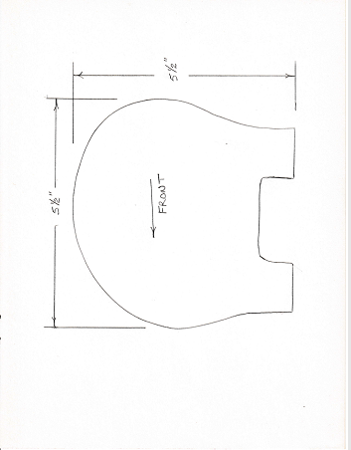

**Attaching a cutting plan to a wood surface . . .**

If you want to attach a pattern to a piece of wood, rather than tracing it, here are two methods you could use. It’s important that the pattern be easy to remove after cutting it out, and that it leaves no residue.

1. The way that I’ve found to be optimal is to use **Scroll Saw Transfer Tape.** The tape I use is 8 ½” wide, and comes in a roll either 5 foot or 20 foot lengths.

* The two sources for the tape are either *The Winfield Collection* [Adhesives, Glues & Wood Filler - Scroll Saw Tape/Adhesive (thewinfieldcollection.com)](https://www.thewinfieldcollection.com/product/Scroll_Saw_Tape_Adhesive/Glue), or *Scroller* [Scroll Saw Tape - Scroll Saw Tape/Adhesive (scrolleronline.com)](http://www.scrolleronline.com/product/Scroll_Saw_Tape/823). I think that they are the same company since they use the same part numbers (SST20 and SST5) and image, but their shipping charges are different
* I also find that this tape comes off easier than blue tape; it’s thinner and not quite as sticky. I also found that it seems to lubricate the blade during use.
* I attach the tape to the wood, pressing down with a “J” roller, peel back the backing paper, lay down the pattern. I then press it down with the “J” roller. After cutting out the pattern, I simply remove the remaining paper and tape. It’s easy to remove, and leaves no sticky residue at all.

1. Other members, who do not have the transfer tape, cover the wood with masking tape, or blue tape. They then spray a contact glue onto the back of the printed plans, and lay that onto the tape-covered wood. When done, peel off the tape along with the paper remains.

Either approach is much easier than trying to remove glued-on paper from the wood once the piece has been cut out!